Project Development Phase
Performance Test

Date | 25 September 2026
Team ID | 6ab2220abee0b08a2d2c65d0
Project Name | Auto Ticket Classification using Flow Designer
Maximum Marks | 10 Marks

Model Performance Testing:
Project team shall fill the following information in model performance testing template.
S.No. | Parameter | Screenshot / Values
1. | Data Rendered | Source: u_incident_workflow (ServiceNow custom table). Records include: Number, Category, Subcategory, State, Caller, Short Description.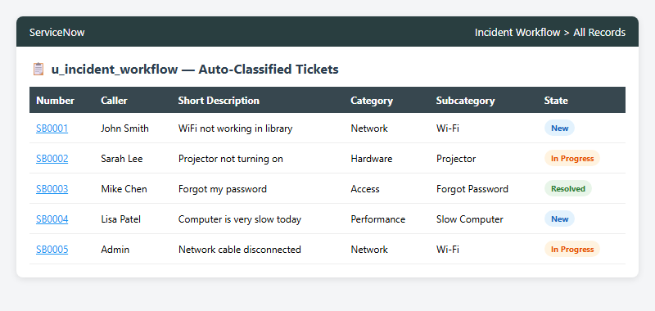
2. | Data Preprocessing | Automated via Business Rule at insert time. Keywords parsed from Short Description to populate Category and Subcategory fields.
3. | Utilization of Filters | ServiceNow list filters used: Category, State, Assigned Group, Created Date. Breadcrumb filters on report dashboards.
4. | Calculation Fields Used | GlideRecord calculated fields: Count of tickets per Category, Average resolution time per Subcategory, Percentage of auto-classified vs manual tickets.
5. | Dashboard Design | No of Visualizations / Graphs: 3 (Tickets by Category Pie, Tickets by State Bar, Full Incident List)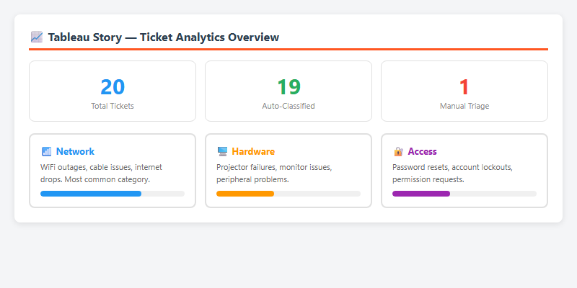
6. | Story Design | No of Visualizations / Graphs: 3 (ServiceNow Homepage Widgets showing real-time ticket distribution and resolution stats)

